**Sprint 3 Report**

**Actions to Stop Doing**

Team should stop placing code in the wrong places so that confusion is minimized amongst team members.

**Actions to Start Doing**

The team should communicate about plans immediately after quizzes so that people separate before heading to the SCRUM meeting.

**Actions to Keep Doing**

The team should keep holding meetings in order to update each other on the project’s progress. The team should also continue to collaborate and help out when the answer is not available from Google.

**Work Completed**

* User Story 1 - As an author, I would like to be able to organize my comic in different ways so that users can read my content more easily and it is easier for me to manage my comics.
* User Story 2 - As an author, I would like to schedule pages/chapters to release automatically so that I can manage my comics more easily.
* User Story 3 - As a reader, I want my images to be scaled to a resolution that is appropriate for my network connection so that they download quickly.
* User Story 4 - As an author, I would like to be able to manipulate my existing comics so that I can manage my comics more easily.
* User Story 5 - As a user, I would like to be able to create a public profile where my biography and comics are publicly displayed so that other users can understand who I am.

As of this report, all 5 of the user stories are complete.

**Burn Up Chart**

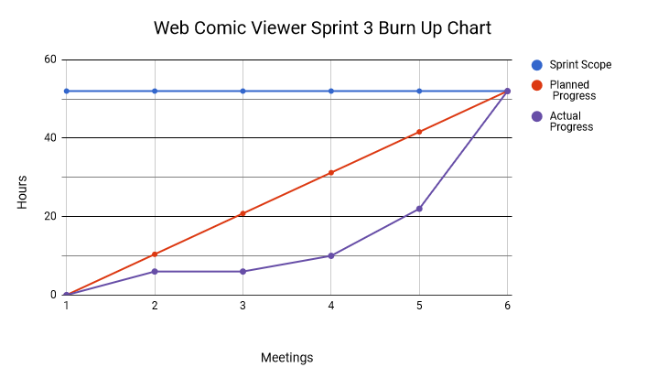

**Work Completion Rate:**

All 5 user stories were completed within Sprint 3. All 5 tasks were completed within 52 ideal hours as originally planned. As the sprint started on February 21, 2018, and ended on March 11, 2018, the sprint took 18 days, 6 of which were weekends. This results in an average ideal work hours per day of 2.89, and 0.278 User Stories per day. By totaling up the statistics of all 3 sprints (74+56+52 Ideal work hours) and (12+15+18 days), the project was completed at a rate of 4.04 ideal work hours per day. As there were a total of 15 user stories over the course of all 3 sprints, which translates to .33 user stories a day over the course of the quarter.